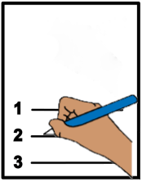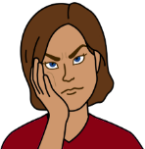

978-1-925885-85-9

**Form**

**Your complaint**

**About you**



First name ___________________________



Last name ___________________________

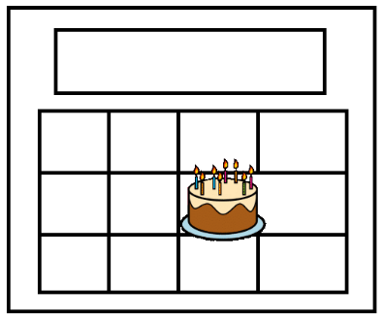

Your birthday ____________________________

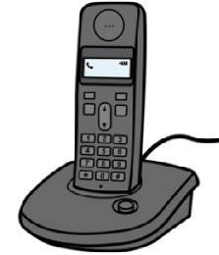

Your phone number _______________________

Your email ______________________________

Your address. This is where you live. ________________________________________________________________________________________________________________________________________________________________________________

Are you



Aboriginal



Yes No.



Torres Strait Islander



Yes No.

Do you speak English?



Yes No.



Do you speak a different language at home?



Yes No.

Do you need an interpreter?

**or**

Do you need help to speak in English?



Yes No.

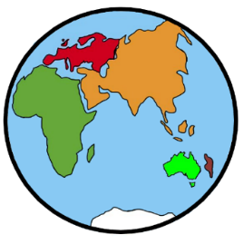

What do you speak? ______________________

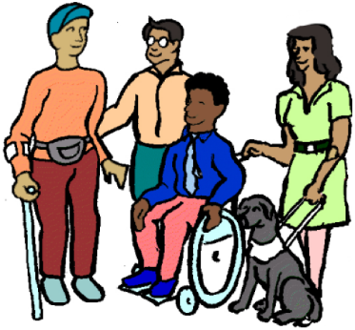Do you have a disability?



Yes No.

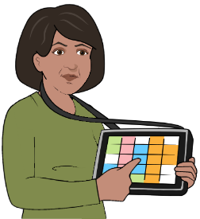

Do you have a communication board?



Yes No.

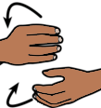

Do you use sign language?



Yes No.



What signs do you use? ___________________

_______________________________________

How can we talk to you?

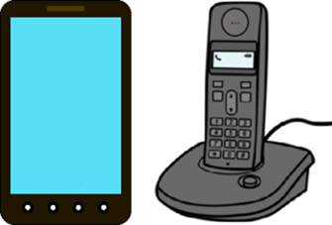

Phone



Face to face



Text



Email

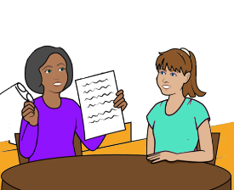Do you need help to make the complaint?



Yes No.

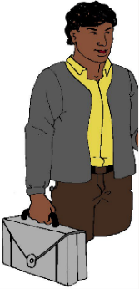

There is some one you trust. Like

* a worker
* a friend.

Can that person be there?



Yes No.

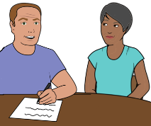Is some one else doing this form for you?



Yes No. Go to

Page 13.

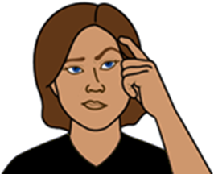How do you know this person? Like they are

* your friend
* a person who helps you at home.

________________________________.

****Who is this person?

First name ___________________________



Last name ___________________________



Phone _______________________________



**The problem**



Who is the complaint about?Like the

* name of the person

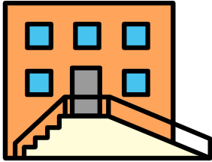 **or**

* the place you were at.





Tell us what the problem is.



______________________________________________________________________________________________________________________________________________________________________________________________________________________________________________________________________________________________________________________________________________________________________________________________________



Have you talked to the person about

the problem?

**or**

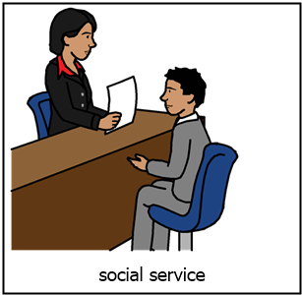

Have you talked to a different person at the organisation about the problem?

Like the

* boss
* manager.



Yes No.



What happened when you talked to them?

________________________________________________________________________________________________________________________________________________________________________________________________________________________________

What do you want to happen? Like

* you want a new worker

**or**

* you want them to change how they talk to you

_______________________________________________________________________________________________________________________________________________________________________________________________________________________________

Do you have other information? Like



* some one saw it happen
* you have a letter
* you have a photo.

Write down what you have.

1 ______________________________________

2 ______________________________________

3 ______________________________________

4. _____________________________________

Some times the NSW Ombudsman



can **not** help you.

**But**

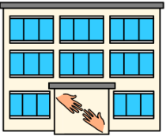

We know who may be able to help.

Can we tell them your complaint?



Yes No.

**Images**



We have used images from

* InspiredServices
* Picto-Selector
* Tobii-Dynavox.

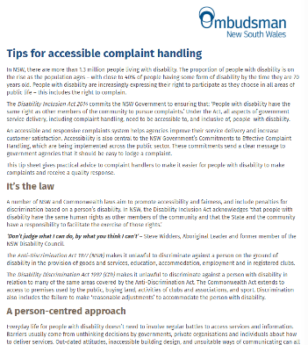

This fact sheet is based on the NSW Ombudsmans Online Complaints Form.

Date 20 October 2016



Access Easy English wrote the Easy English.

July 2021.

ISBN: 978-1-925885-86-6